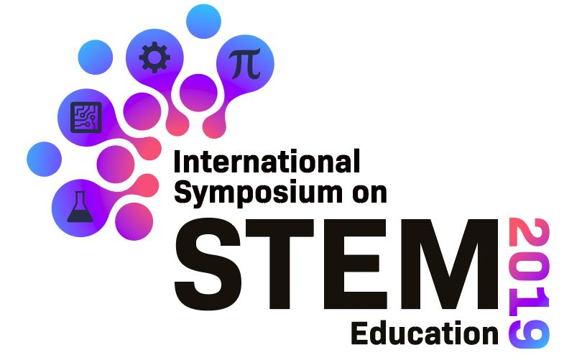

Microsoft Hands on Experience:

At the Symposium, we will organise a AI hands on expereiene by Microsoft. In this workshop, you will learn about how to apply AI technologies through an Application Programming Interface (API). You can find out more at Azure Face API website.

On the other hand, you will also learn about data analysis and visualization with PowerBI, a data visualization tool from Microsoft. We will learn about creating a report in PowerBI.

After this workship, you are free to make use of these new technology in the final pitching presentation. Here are some useful links to get yourself familiar before the workshop:

Azure Cognitive Service Face API: https://azure.microsoft.com/en-us/services/cognitive-services/face/#detection
Create your first Power BI report: https://docs.microsoft.com/en-us/learn/modules/build-your-first-power-bi-report/

